**PROJECT REPORT**

on

# Developing a web/mobile app of people networks.

# (CSE VI Semester Mini project)

# 2021-2022

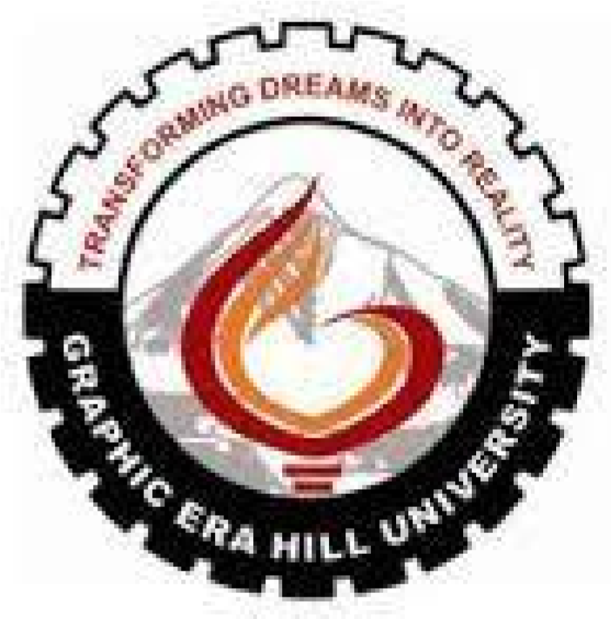

|  |  |
| --- | --- |
| **Submitted to:** | **Submitted by:** |
| Dr. Indrajeet | Ashutosh Baunthiyal |
| (CC-CSE-G-VI-Sem) | Roll. No.: 1918275 |
|  | CSE-G-VI-Sem |
|  | Session: 2021-2022 |

**DEPARTMENT OF COMPUTER SCIENCE AND INFORMATION TECHNOLOGY**

**GRAPHIC ERA HILL UNVERSITY, DEHRADUN**

**CERTIFICATE**

Certified that **Ashutosh Baunthiyal** (Roll No: - 1918275) has developed mini project on “**Developing a mobile app of people networks using data from LinkedIn.”** for the CS **VI** Semester Mini Project Lab in Graphic Era Hill University, Dehradun. The project carried out by Students is their own work as best of my knowledge.

Date:

(Dr. Indrajeet)

**Project Co-ordinator**

**CC-CSE-G-VI-Sem**

(CSE Department)

GEHU Dehradun

**ACKNOWLEDGMENT**

We would like to express our gratitude to The Almighty Shiva Baba, the most Beneficent and the most Merciful, for completion of project.

We wish to thank our parents for their continuing support and encouragement. We also wish to thank them for providing us with the opportunity to reach this far in our studies.

We would like to thank particularly our project Dr. Indrajeet for his patience, support and encouragement throughout the completion of this project and having faith in us.

At last but not the least we greatly indebted to all other persons who directly or indirectly helped us during this work.

# Ashutosh Baunthiyal

# Roll No: - 1918275

# CSE-G-VI-Sem

# Session:2021-2022

# GEHU, Dehradun

**TABLE OF CONTENT**

**CHAPTER NO.1 1. Abstract**

**CHAPTER NO.2**

**2. Introduction**

## 2.1 Problem Statement and Motivation

**CHAPTER NO.3**

1. **Aims and Objectives**

**CHAPTER NO.4**

1. **Screen Shot**

**CHAPTER NO.5**

1. **Conclusion**

**REFERENCE**

**Abstract**

**LinkedIn** is an American business and employment-oriented online service that operates via websites and mobile apps. Launched on May 5, 2003, the platform is primarily used for professional networking and career development, and allows job seekers to post their CVs and employers to post jobs. From 2015 most of the company's revenue came from [selling access to information about its members](https://en.wikipedia.org/wiki/Information_broker) to recruiters and sales professionals. Since December 2016, it has been a wholly owned subsidiary of [Microsoft.](https://en.wikipedia.org/wiki/Microsoft) As of September 2021, LinkedIn has 774+ million registered members from over 200 countries and territories.

LinkedIn allows members (both workers and employers) to create profiles and connect with each other in an online social network which may represent real-world professional relationships. Members can invite anyone (whether an existing member or not) to become a connection. LinkedIn can also be used to organize offline events, join groups, write articles, publish job postings, post photos and videos, and more.

**React Native** is an open-source UI software framework created by Meta Platforms, Inc. It is used to develop applications for Android, Android TV, iOS, macOS, tv OS, Web, Windows and UWP by enabling developers to use the React framework along with native platform capabilities. It is also being used to develop virtual reality applications at Oculus.

**Node.js** is an open-source, cross-platform, back-end JavaScript runtime environment that runs on the V8 engine and executes JavaScript code outside a web browser, which was designed to build scalable network applications. Node.js lets developers use JavaScript to write command line tools and for server-side scripting—running scripts server-side to produce dynamic web page content before the page is sent to the user's web browser. Consequently, Node.js represents a "JavaScript everywhere" paradigm, unifying web-application development around a single programming language, rather than different languages for server-side and client-side scripts.

Node.js has an event-driven architecture capable of asynchronous I/O. These design choices aim to optimize throughput and scalability in web applications with many input/output operations, as well as for real-time Web applications (e.g., real-time communication programs and browser games).

Corporate users of Node.js software include GoDaddy, Groupon, IBM, LinkedIn, Microsoft, Netflix, PayPal, Rakuten, SAP, Walmart, Yahoo!, and Amazon Web Services.

**MongoDB** is a source-available cross-platform document-oriented database program. Classified as a NoSQL database program, MongoDB uses JSON-like documents with optional schemas.

MongoDB is developed by MongoDB Inc. and licensed under the Server Side Public License

(SSPL) which is deemed non-free by several distribution

# Introduction

The main objective of this project is to connect people with similar skills and interests. linkedln connects multiple people, who have different aspects in their lives. So, this app helps to connect or group people according to their skill sets and their projects.

I found myself struggling to get any leads when looking for my first real job or position… I then amped up my search by utilizing linkedIn, research companies, identify contacts and hiring managers and began reaching out to actual people.

LinkedIn- we know it as the world’s largest professional network that enables users to share an update about their professional activities. Be it changing a job or completion of a project, LinkedIn has remained a preferred social media platform for professionals.

The data on LinkedIn is largely based on corporate life and business communities have embraced this platform for getting the reference of individuals. Its growing popularity worldwide is one of the major reasons why mobile app developers tend to integrate it with Android applications.

Integration of LinkedIn with existing Android apps can offer a plethora of advantages. One of them is users can share various information about their career without exiting from the app.

Let’s go through a step-by-step process of integrating LinkedIn with Android apps.

**Is React Native used for front end?**

Yes, to give you a gentle introduction, which was developed by Facebook. Its componentbased library lets you build high-quality user-interfaces for web apps.

Once we open the app, there are several icons and thumbnails to select which will be selected by the user to interact or to connects with the similar types of people who have same skills and opportunity.

These thumbnails will be responsible for the interaction between the user and the end-server.

Back-end is still under development or still on preparation for final touch.

As a whole a perfect UI is created to demonstrate the working of the app.

As for the result I have created a UI is ready to give a glimpse of the project.

**How other social media do!**

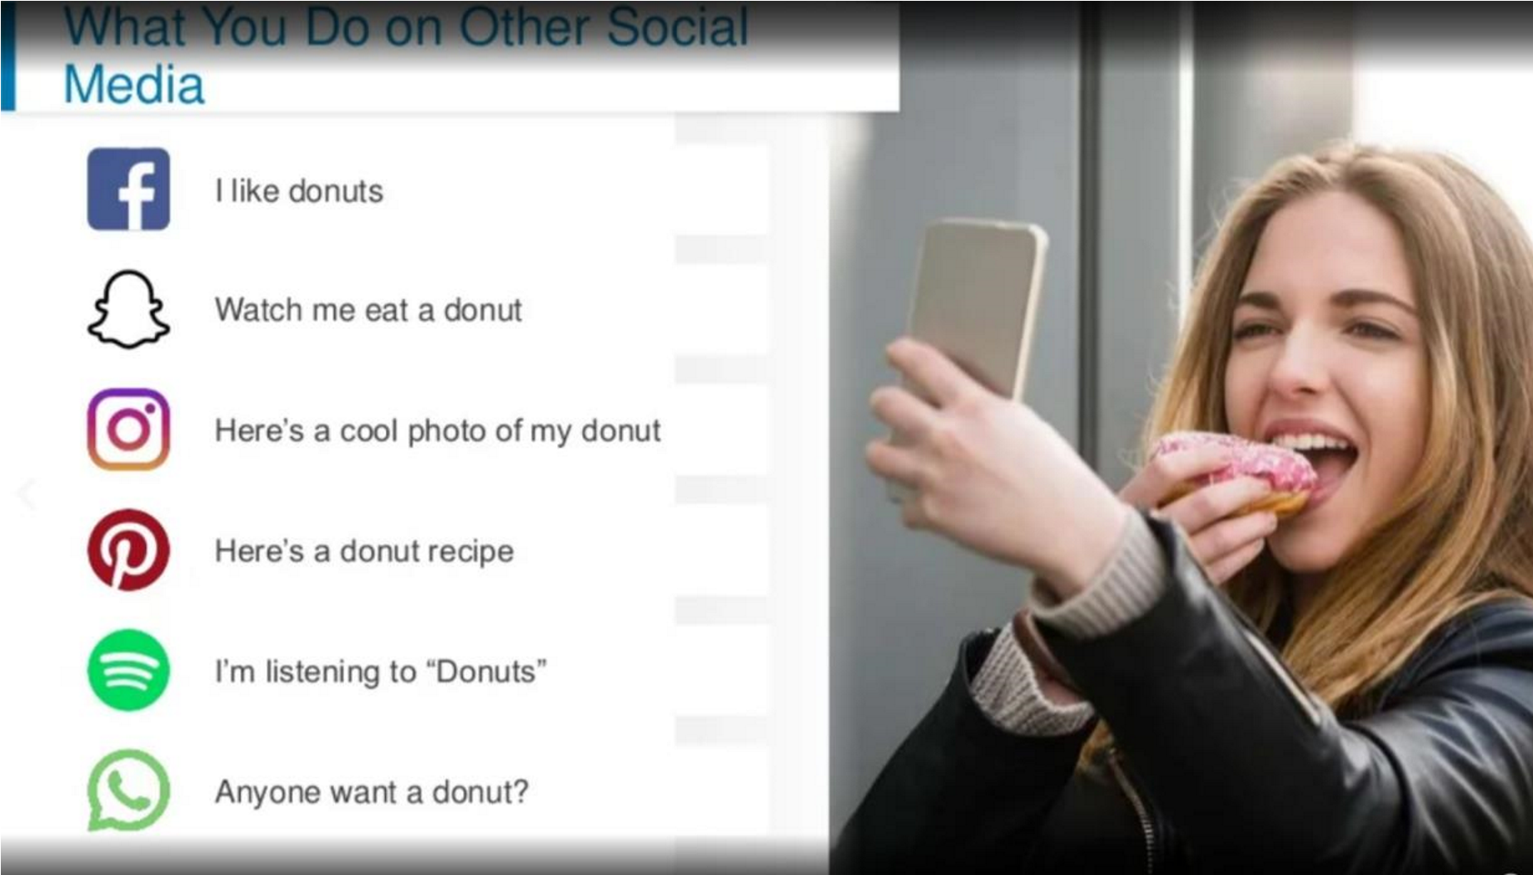

**How Linkedln give us!**

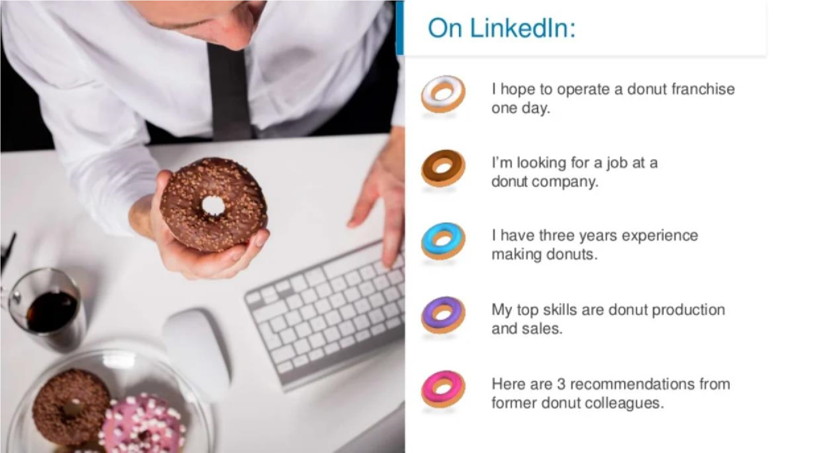

# How our app shows

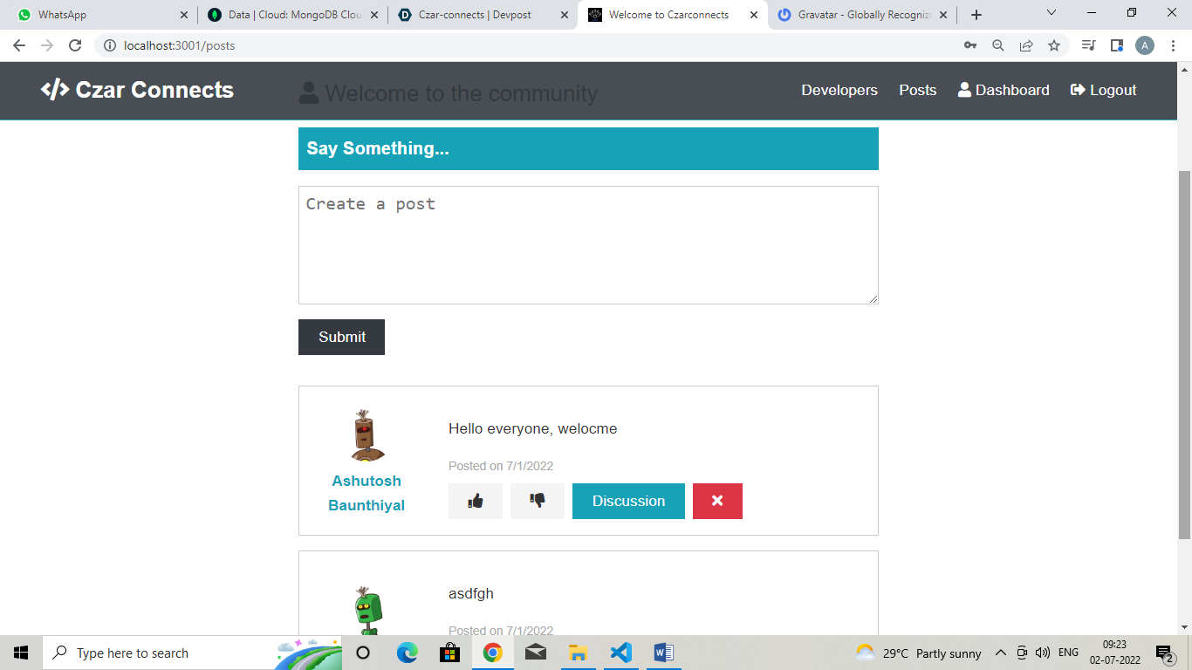

* **Problem Statement and Motivation**

According to the people networks using data from LinkedIn, the accuracy of the data collected is the biggest issue. This is because the people networks using data from LinkedIn might not be recorded personally by the original person, in another word, the people networks using data from LinkedIn of a particular person can be taken by a third party without the realization of the institution which violates the accuracy of the data.

* **Building a Great Student Profile**

Many students can be found struggling to get any leads when looking for my first real job or position. I then amped up my search by utilizing linkedIn, research companies, identify contacts and hiring managers and began reaching out to actual people and found that it may be tiring way to do it. This project allows people with similar skills and interests. Linkedln connects multiple people, who have different aspects in their lives. So, this app helps to connect or group people according to their skill sets and their projects.

* **What Motivates to develop this app**

The data on LinkedIn is largely based on corporate life and business communities have embraced this platform for getting the reference of individuals. Its growing popularity worldwide is one of the major reasons why mobile app developers tend to integrate it with Android applications.

* **Aims and Objectives**

The objective of this project is to developa mobile app of people networks using data from LinkedIn. Expected achievements in order to fulfill the objectives are:

* To gain information of people through Linkedln.

* To compare their skills with the subsets.

* To classify their interests and project works

# Code snippet

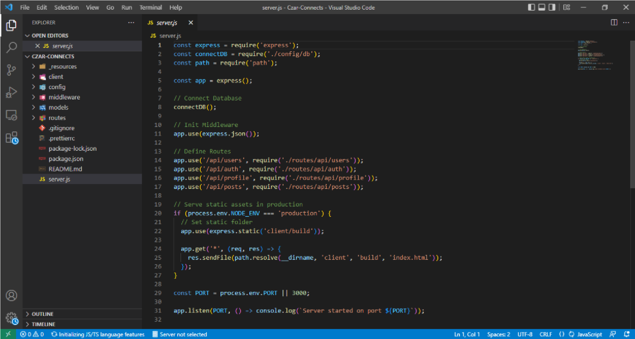

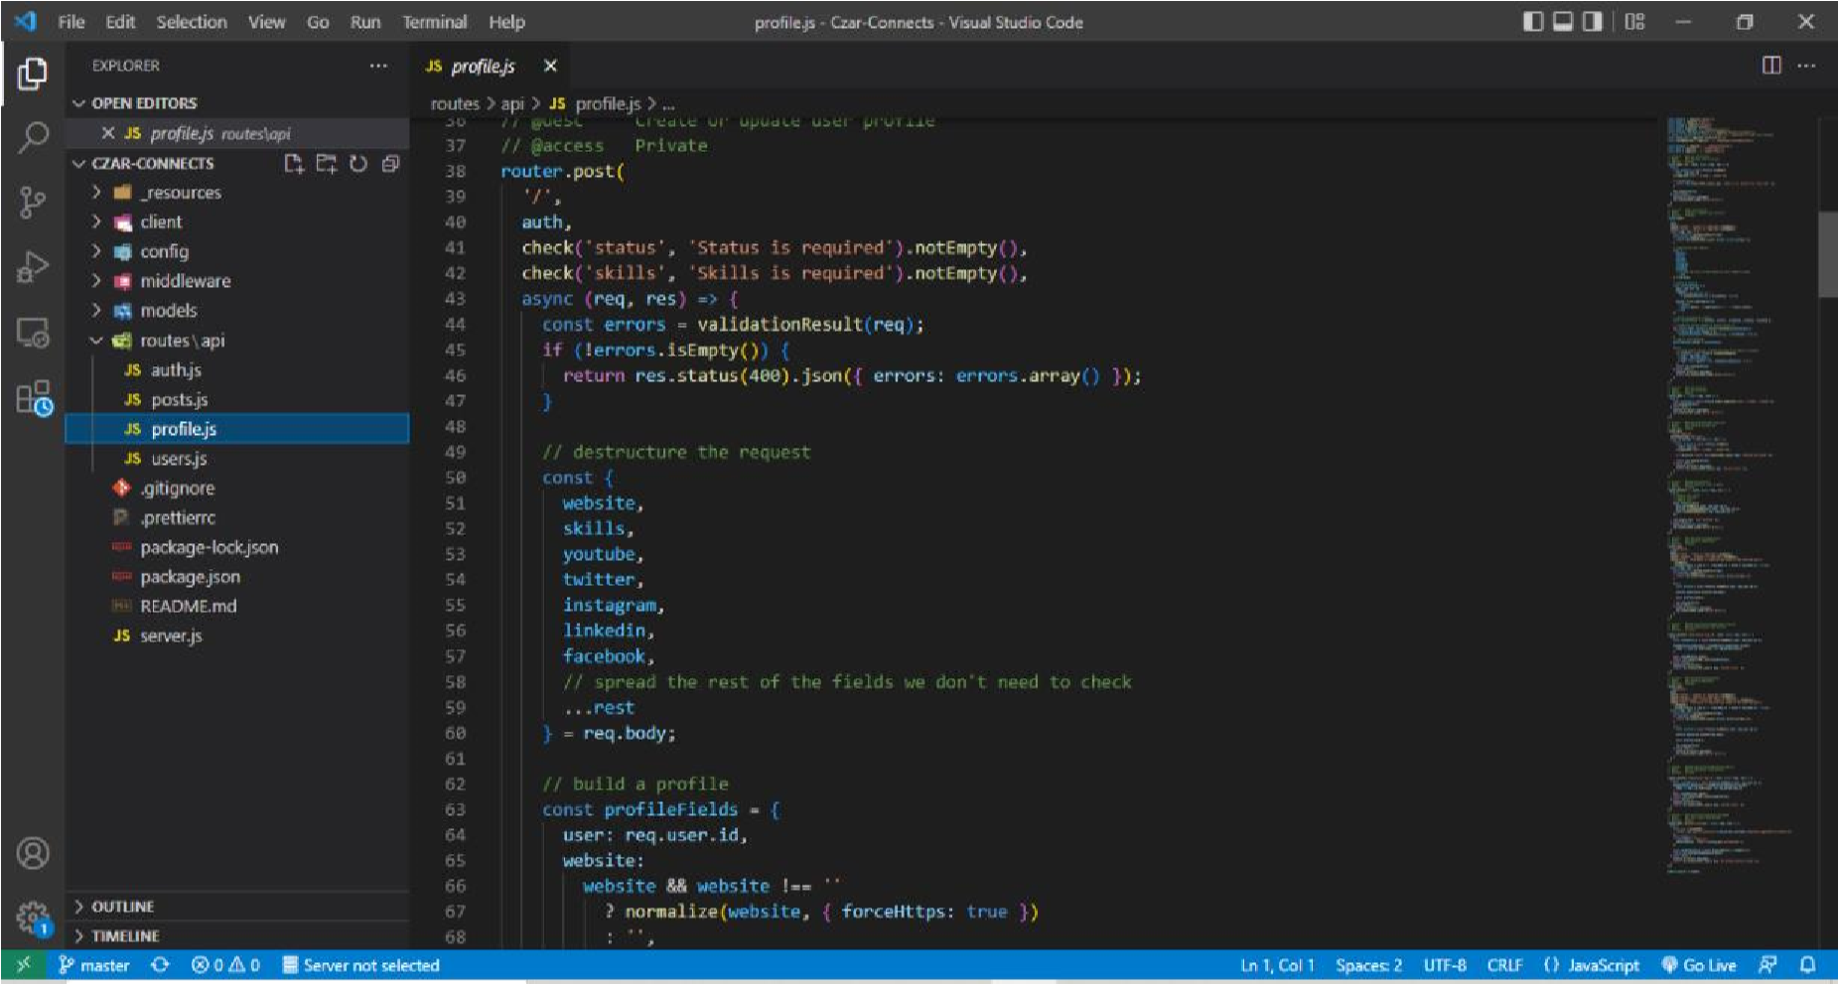

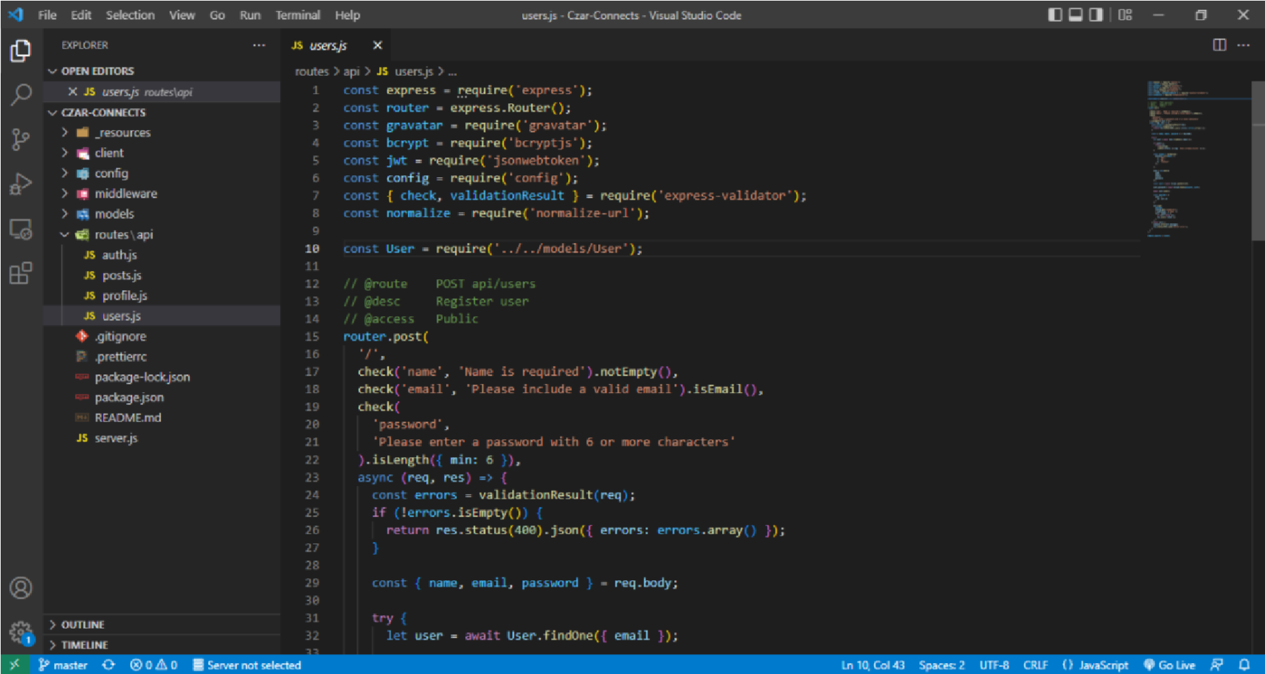

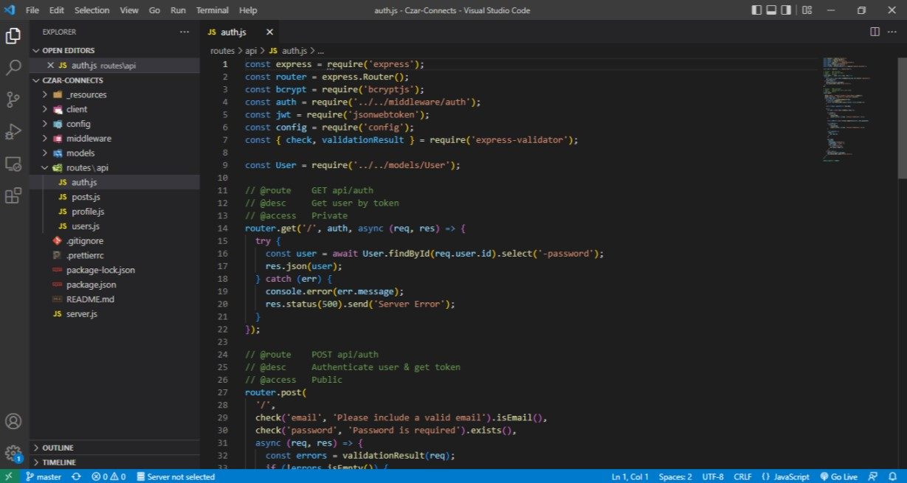

# CONCLUSION

For the conclusion, this project uses people networks using data from LinkedIn, the accuracy of the data collected is the biggest issue. This is because the people networks using data from LinkedIn might not be recorded personally by the original person, in another word, the people networks using data from LinkedIn of a particular person can be taken by a third party without the realization of the institution which violates the accuracy of the data. Therefore it will help people to connect with others with similar interests and skills which can reduce efforts while searching for it in LikedIn app.

# Future Work

Further work can be done this project to group people according to their jobs and relevant future skill sets.

# REFERENCES

1. J. Chin, E. Tsun, C. W. Jen, F. Choong, and C. Mei, “Data Manipulation and Extraction,” 2014.
2. <https://www.udemy.com/course/building-a-linkedin-clone-with-no-code-using-bubble/>
3. U. A. Patel, “Computer Science and Management Studies Development of a MongoDB server using RFID: A Review,”Int.J.Adv Res., vol. 2, no.8, pp. 109-119, 2016 [4]